**Create a Spring Web Project using Maven**

**Code:**

**SpringLearnApplication.java**

package com.cognizant.spring_learn;

import org.springframework.boot.SpringApplication;

import org.springframework.boot.autoconfigure.SpringBootApplication;

@SpringBootApplication

public class SpringLearnApplication {

public static void main(String[] args) {

System.out.println("START");

SpringApplication.run(SpringLearnApplication.class, args);

System.out.println("END");

}

}

**HelloController.java**

package com.cognizant.spring_learn;

import org.springframework.web.bind.annotation.GetMapping;

import org.springframework.web.bind.annotation.RestController;

@RestController

public class HelloController {

@GetMapping("/hello")

public String sayHello() {

return "Hello Spring!";

}

}

**application.properties**

spring.application.name=spring-learn

server.port=9090

**Output:**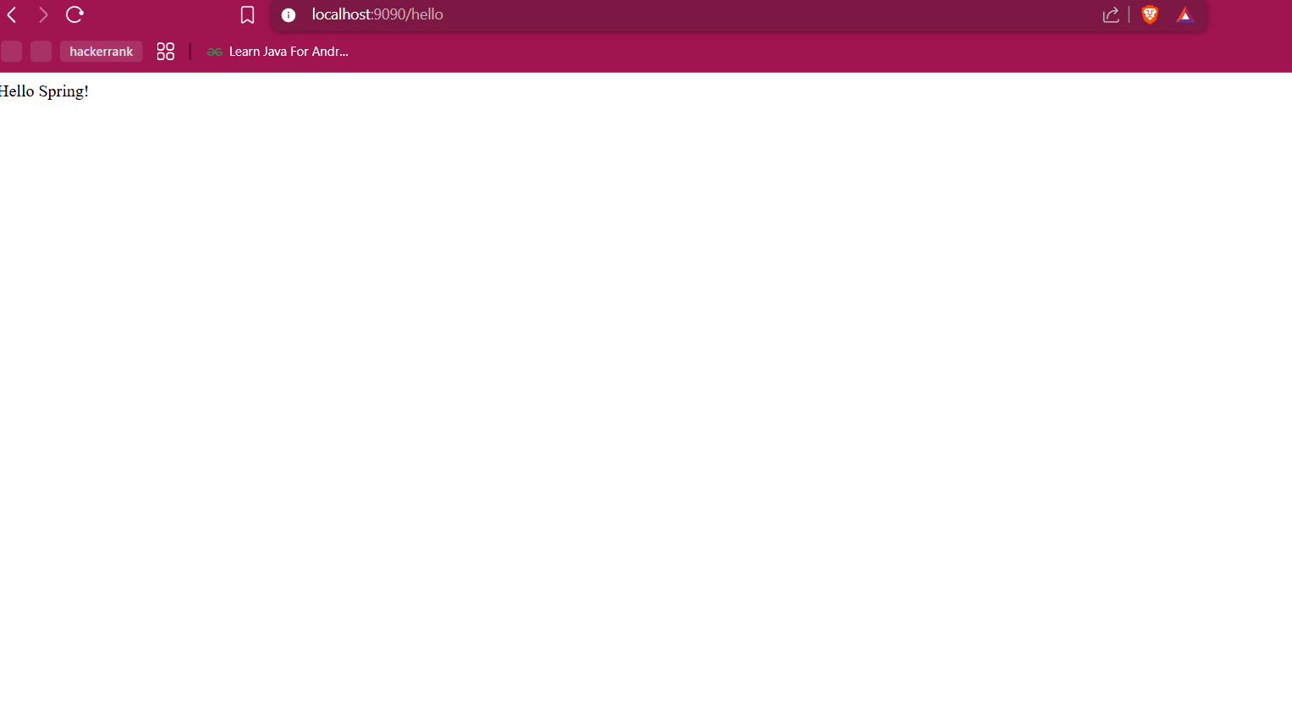

**Hands on 4**

**Spring Core – Load Country from Spring Configuration XML**

**Code:**

**SpringLearnApplication.java**

package com.cognizant.springlearn;

import org.slf4j.Logger;

import org.slf4j.LoggerFactory;

import org.springframework.context.ApplicationContext;

import org.springframework.context.support.ClassPathXmlApplicationContext;

public class SpringLearnApplication {

private static final Logger ***LOGGER*** = LoggerFactory.*getLogger*(SpringLearnApplication.class);

public static void main(String[] args) {

***LOGGER***.info("START");

*displayCountry*();

***LOGGER***.info("END");

}

public static void displayCountry() {

ApplicationContext context = new ClassPathXmlApplicationContext("country.xml");

Country country = context.getBean("country", Country.class);

***LOGGER***.debug("Country : {}", country.toString());

}

}

**Country.java**

package com.cognizant.springlearn;

import org.slf4j.Logger;

import org.slf4j.LoggerFactory;

public class Country {

private static final Logger ***LOGGER*** = LoggerFactory.*getLogger*(Country.class);

private String code;

private String name;

public Country() {

***LOGGER***.debug("Inside Country Constructor.");

}

public String getCode() {

***LOGGER***.debug("Inside getCode()");

return code;

}

public void setCode(String code) {

***LOGGER***.debug("Inside setCode()");

this.code = code;

}

public String getName() {

***LOGGER***.debug("Inside getName()");

return name;

}

public void setName(String name) {

***LOGGER***.debug("Inside setName()");

this.name = name;

}

*@Override*

public String toString() {

return "Country [code=" + code + ", name=" + name + "]";

}

}

**Country.xml**

<?xml version=*"1.0"* encoding=*"UTF-8"*?>

<beans xmlns=*"http://www.springframework.org/schema/beans"*

xmlns:xsi=*"http://www.w3.org/2001/XMLSchema-instance"*

xsi:schemaLocation=*"http://www.springframework.org/schema/beans*

*http://www.springframework.org/schema/beans/spring-beans.xsd"*>

<bean id=*"country"* class=*"com.cognizant.springlearn.Country"*>

<property name=*"code"* value=*"IN"* />

<property name=*"name"* value=*"India"* />

</bean>

</beans>

**Simplelogger.properties:**

org.slf4j.simpleLogger.defaultLogLevel=debug

**Output:**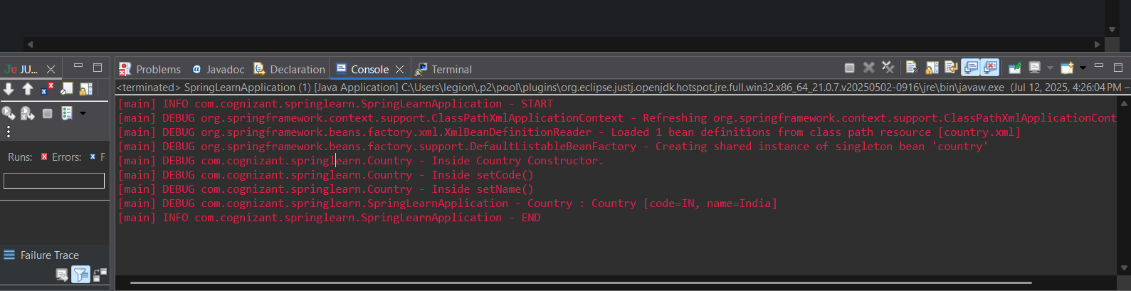

**Hello World RESTful Web Service**

**Code:**

**SpringHelloApplication.java**

package com.cognizant.spring_hello;

import org.springframework.boot.SpringApplication;

import org.springframework.boot.autoconfigure.SpringBootApplication;

*@SpringBootApplication*

public class SpringHelloApplication {

public static void main(String[] args) {

SpringApplication.*run*(SpringHelloApplication.class, args);

}

}

**HelloController.java:**  
package com.cognizant.spring_hello;

import org.slf4j.Logger;

import org.slf4j.LoggerFactory;

import org.springframework.web.bind.annotation.GetMapping;

import org.springframework.web.bind.annotation.RestController;

*@RestController*

public class HelloController {

private static final Logger ***LOGGER*** = LoggerFactory.*getLogger*(HelloController.class);

*@GetMapping*("/hello")

public String sayHello() {

***LOGGER***.info("START - /hello endpoint");

***LOGGER***.info("END - /hello endpoint");

return "Hello World!!";

}

}

**Application.properties :**

spring.application.name=spring-hello

server.port=8085

**Output:**

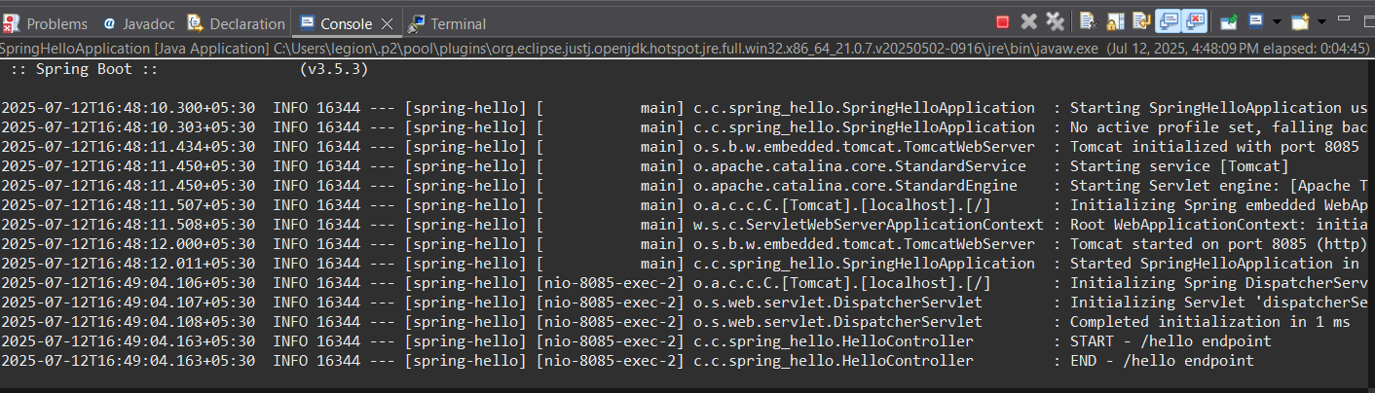

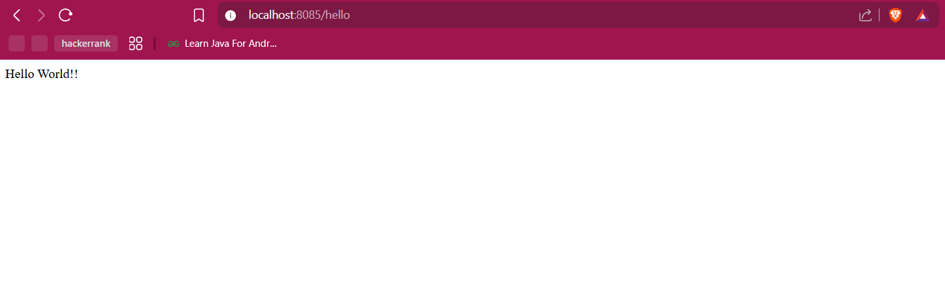  
**REST - Country Web Service**

**Code:  
country.xml:**<?xml version="1.0" encoding="UTF-8"?>

<beans xmlns="http://www.springframework.org/schema/beans"

xmlns:xsi="http://www.w3.org/2001/XMLSchema-instance"

xsi:schemaLocation="http://www.springframework.org/schema/beans

https://www.springframework.org/schema/beans/spring-beans.xsd">

<bean id="country" class="com.cognizant.springlearn.Country">

<property name="code" value="IN" />

<property name="name" value="India" />

</bean>

</beans>  
**Country.java:**package com.cognizant.springlearn;

public class Country {

private String code;

private String name;

public Country() {

System.out.println("Inside Country Constructor");

}

public String getCode() {

System.out.println("Inside getCode()");

return code;

}

public void setCode(String code) {

System.out.println("Inside setCode()");

this.code = code;

}

public String getName() {

System.out.println("Inside getName()");

return name;

}

public void setName(String name) {

System.out.println("Inside setName()");

this.name = name;

}

@Override

public String toString() {

return "Country [code=" + code + ", name=" + name + "]";

}

}

**SpringLearnApplication.java:**

package com.cognizant.spring_learn;

import org.springframework.boot.SpringApplication;

import org.springframework.boot.autoconfigure.SpringBootApplication;

*@SpringBootApplication*

public class SpringLearnApplication {

public static void main(String[] args) {

SpringApplication.*run*(SpringLearnApplication.class, args);

}

}

**Output:**  
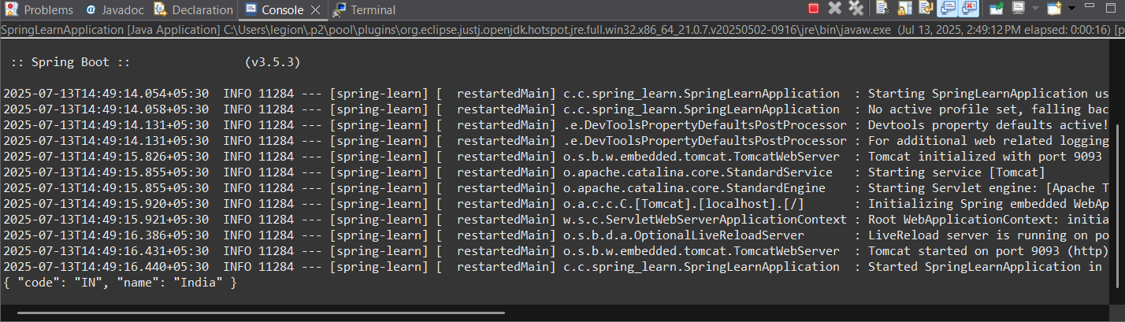

**REST - Get country based on country code**

**Code:  
SpringCountryApiApplication.java**

package com.cognizant.spring_country_api;

import org.springframework.boot.SpringApplication;

import org.springframework.boot.autoconfigure.SpringBootApplication;

*@SpringBootApplication*

public class SpringCountryApiApplication {

public static void main(String[] args) {

SpringApplication.*run*(SpringCountryApiApplication.class, args);

}

}

**Country.java:**

package com.cognizant.springcountryapi.model;

public class Country {

private String code;

private String name;

public Country() {}

public Country(String code, String name) {

this.code = code;

this.name = name;

}

public String getCode() {

return code;

}

public void setCode(String code) {

this.code = code;

}

public String getName() {

return name;

}

public void setName(String name) {

this.name = name;

}

*@Override*

public String toString() {

return "Country [code=" + code + ", name=" + name + "]";

}

}

**CountryApplication.java:**  
package com.cognizant.spring_country_api.controller;

import com.cognizant.springcountryapi.model.Country;

import com.cognizant.springcountryapi.service.CountryService;

import org.springframework.beans.factory.annotation.Autowired;

import org.springframework.web.bind.annotation.*;

*@RestController*

public class CountryController {

*@Autowired*

private CountryService countryService;

*@GetMapping*("/countries/{code}")

public Country getCountry(*@PathVariable* String code) {

return countryService.getCountry(code);

}

}

**Countryservice.java:**package com.cognizant.springcountryapi.service;

import com.cognizant.springcountryapi.model.Country;

import org.springframework.context.ApplicationContext;

import org.springframework.context.support.ClassPathXmlApplicationContext;

import org.springframework.stereotype.Service;

import java.util.List;

*@Service*

public class CountryService {

public Country getCountry(String code) {

ApplicationContext context = new ClassPathXmlApplicationContext("country.xml");

List<Country> countryList = context.getBean("countryList", List.class);

return countryList.stream()

.filter(c -> c.getCode().equalsIgnoreCase(code))

.findFirst()

.orElse(null);

}

}

**Country.xml:**<?**xml** version=*"1.0"* encoding=*"UTF-8"*?>

<**beans** xmlns=*"http://www.springframework.org/schema/beans"*

xmlns:xsi=*"http://www.w3.org/2001/XMLSchema-instance"*

xsi:schemaLocation=*"http://www.springframework.org/schema/beans*

*https://www.springframework.org/schema/beans/spring-beans.xsd"*>

<**bean** id=*"countryList"* class=*"java.util.ArrayList"*>

<**constructor-arg**>

<**list**>

<**bean** class=*"com.cognizant.springcountryapi.model.Country"*>

<**property** name=*"code"* value=*"IN"*/>

<**property** name=*"name"* value=*"India"*/>

</**bean**>

<**bean** class=*"com.cognizant.springcountryapi.model.Country"*>

<**property** name=*"code"* value=*"US"*/>

<**property** name=*"name"* value=*"United States"*/>

</**bean**>

<**bean** class=*"com.cognizant.springcountryapi.model.Country"*>

<**property** name=*"code"* value=*"DE"*/>

<**property** name=*"name"* value=*"Germany"*/>

</**bean**>

<**bean** class=*"com.cognizant.springcountryapi.model.Country"*>

<**property** name=*"code"* value=*"JP"*/>

<**property** name=*"name"* value=*"Japan"*/>

</**bean**>

</**list**>

</**constructor-arg**>

</**bean**>

</**beans**>

**Output:**  


**Create authentication service that returns JWT**   
  
**Code:**  
**JwtAuthServiceApplication.java :**  
package com.cognizant.jwt_auth_service;

import org.springframework.boot.SpringApplication;

import org.springframework.boot.autoconfigure.SpringBootApplication;

*@SpringBootApplication*

public class JwtAuthServiceApplication {

public static void main(String[] args) {

SpringApplication.*run*(JwtAuthServiceApplication.class, args);

}

}  
  
**SecurityConfig.java :**  
  
package com.cognizant.jwt_auth_service.config;

import org.springframework.context.annotation.Bean;

import org.springframework.context.annotation.Configuration;

import org.springframework.security.config.annotation.web.configuration.EnableWebSecurity;

import org.springframework.security.web.SecurityFilterChain;

import org.springframework.security.config.annotation.web.builders.HttpSecurity;

*@Configuration*

*@EnableWebSecurity*

public class SecurityConfig {

*@Bean*

public SecurityFilterChain filterChain(HttpSecurity http) throws Exception {

http

.authorizeHttpRequests(auth -> auth

.requestMatchers("/authenticate").permitAll()

.anyRequest().authenticated()

)

.csrf().disable();

return http.build();

}

}

**AuthenticationController.java :**

package com.cognizant.jwt_auth_service.controller;

import org.springframework.web.bind.annotation.GetMapping;

import org.springframework.web.bind.annotation.RestController;

*@RestController*

public class AuthenticationController {

*@GetMapping*("/authenticate")

public String authenticate() {

return "{\"token\": \"This will be a real JWT soon\"}";

}

}  
**application.properties:**

spring.application.name=jwt-auth-service

server.port=8090

**Output :**